A2614-Eur-Celtic-Seated Figure-Bronze-3rd c CE

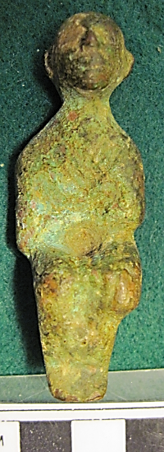 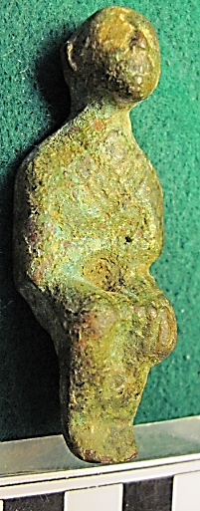 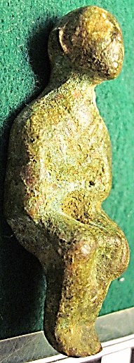

Figs. 1-3. Eur-Celtic-Seated Figure-Bronze-3rd c CE

**Case no.: 4**

**Accession Number: A2614**

**Formal Label:** Eur-Celtic-Seated Figure-Bronze-3rd c CE

**Display Description:**

This is a rare Irish Celtic ‘Patrona,’ a bronze anthropomorphic seated male figurine, c 3rd century CE. Both hands are molded and placed on the knees as though receptive to a votive request. The face is depicted uplifted which is typical of Irish Iron Age art. The figure is wearing a tunic with a “V” shaped neck, perhaps suggesting its identity as a deity.

**LC Classification:**

**Date or Time Horizon:** c 3rd century CE

**Geographical Area:** Ireland

**Map:**

**GPS coordinates:**

**Cultural Affiliation:** Irish Celtic

**Medium:** bronze

**Dimensions:** H 61.27 mm, 2.14 in

**Weight:**

**Condition: original**

**Provenance:**

**Discussion:**